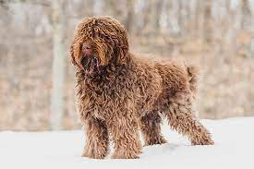

**Barbet**

Barbet dog breed

Origin: France Height: 19-25 inches Weight: 40-65 pounds Lifespan: 12-15 years

Description: The Barbet is a large, curly-coated dog that is known for its intelligence, trainability, and gentle nature. They are excellent swimmers and enjoy water activities. Barbets are also very loyal and affectionate dogs that make great companions.

Key features:

* Curly, hypoallergenic coat
* Intelligent and trainable
* Gentle and affectionate
* Excellent swimmer

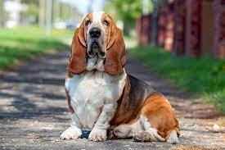

**Basset Hound**

Basset Hound dog breed

Origin: France Height: 13-15 inches Weight: 40-65 pounds Lifespan: 10-13 years

Description: The Basset Hound is a low-slung, short-legged dog that is known for its long ears, droopy eyes, and laid-back personality. They are gentle and affectionate dogs that make great family pets. Basset Hounds are also excellent scent hounds and are often used for hunting.

Key features:

* Long ears and droopy eyes
* Gentle and affectionate
* Excellent scent hound

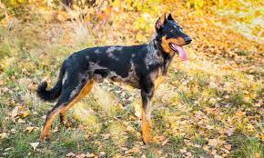

**Beauceron**

Beauceron dog breed

Origin: France Height: 24-28 inches Weight: 60-80 pounds Lifespan: 10-12 years

Description: The Beauceron is a large, muscular dog that is known for its intelligence, athleticism, and loyalty. They are versatile working dogs that are used for herding, guarding, and police work. Beaucerons are also excellent family pets and are very protective of their owners.

Key features:

* Intelligent and athletic
* Loyal and protective
* Versatile working dog

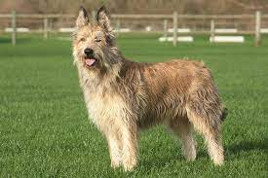

**Berger Picard**

Berger Picard dog breed

Origin: France Height: 21-26 inches Weight: 45-60 pounds Lifespan: 10-12 years

Description: The Berger Picard is a medium-sized, herding dog that is known for its intelligence, energy, and athleticism. They are versatile working dogs that are used for herding, guarding, and police work. Berger Picards are also very loyal and affectionate companions.

Key features:

* Intelligent and athletic
* Versatile working dog
* Loyal and affectionate companion

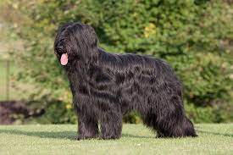

**Briard**

Briard dog breed

Origin: France Height: 22-27 inches Weight: 50-100 pounds Lifespan: 10-12 years

Description: The Briard is a large, fluffy dog that is known for its distinctive long, shaggy coat. They are intelligent and trainable dogs that are used for herding, guarding, and police work. Briards are also very loyal and affectionate companions.

Key features:

* Distinctive long, shaggy coat
* Intelligent and trainable
* Loyal and affectionate companion

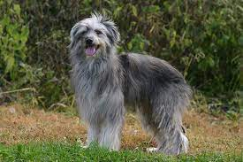

**Pyrenean Sheepdog**

Pyrenean Sheepdog dog breed

Origin: France Height: 20-30 inches Weight: 70-150 pounds Lifespan: 10-12 years

Description: The Pyrenean Sheepdog is a large, fluffy dog that is known for its distinctive white coat. They are hardworking herding dogs that are very protective of their flock. Pyrenean Sheepdogs are also loyal and affectionate companions.

Key features:

* Distinctive white coat
* Hardworking herding dog
* Loyal and affectionate companion

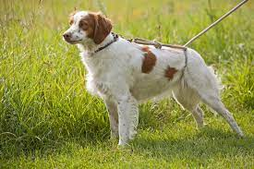

**Brittany**

Brittany dog breed

Origin: France Height: 17-21 inches Weight: 30-40 pounds Lifespan: 10-13 years

Description: The Brittany is a medium-sized, pointing dog that is known for its intelligence, energy, and athleticism. They are versatile working dogs that are used for hunting, pointing, and retrieving. Brittanys are also very loyal and affectionate companions.

Key features:

* Intelligent, energetic, and athletic
* Versatile working dog
* Loyal and affectionate companion